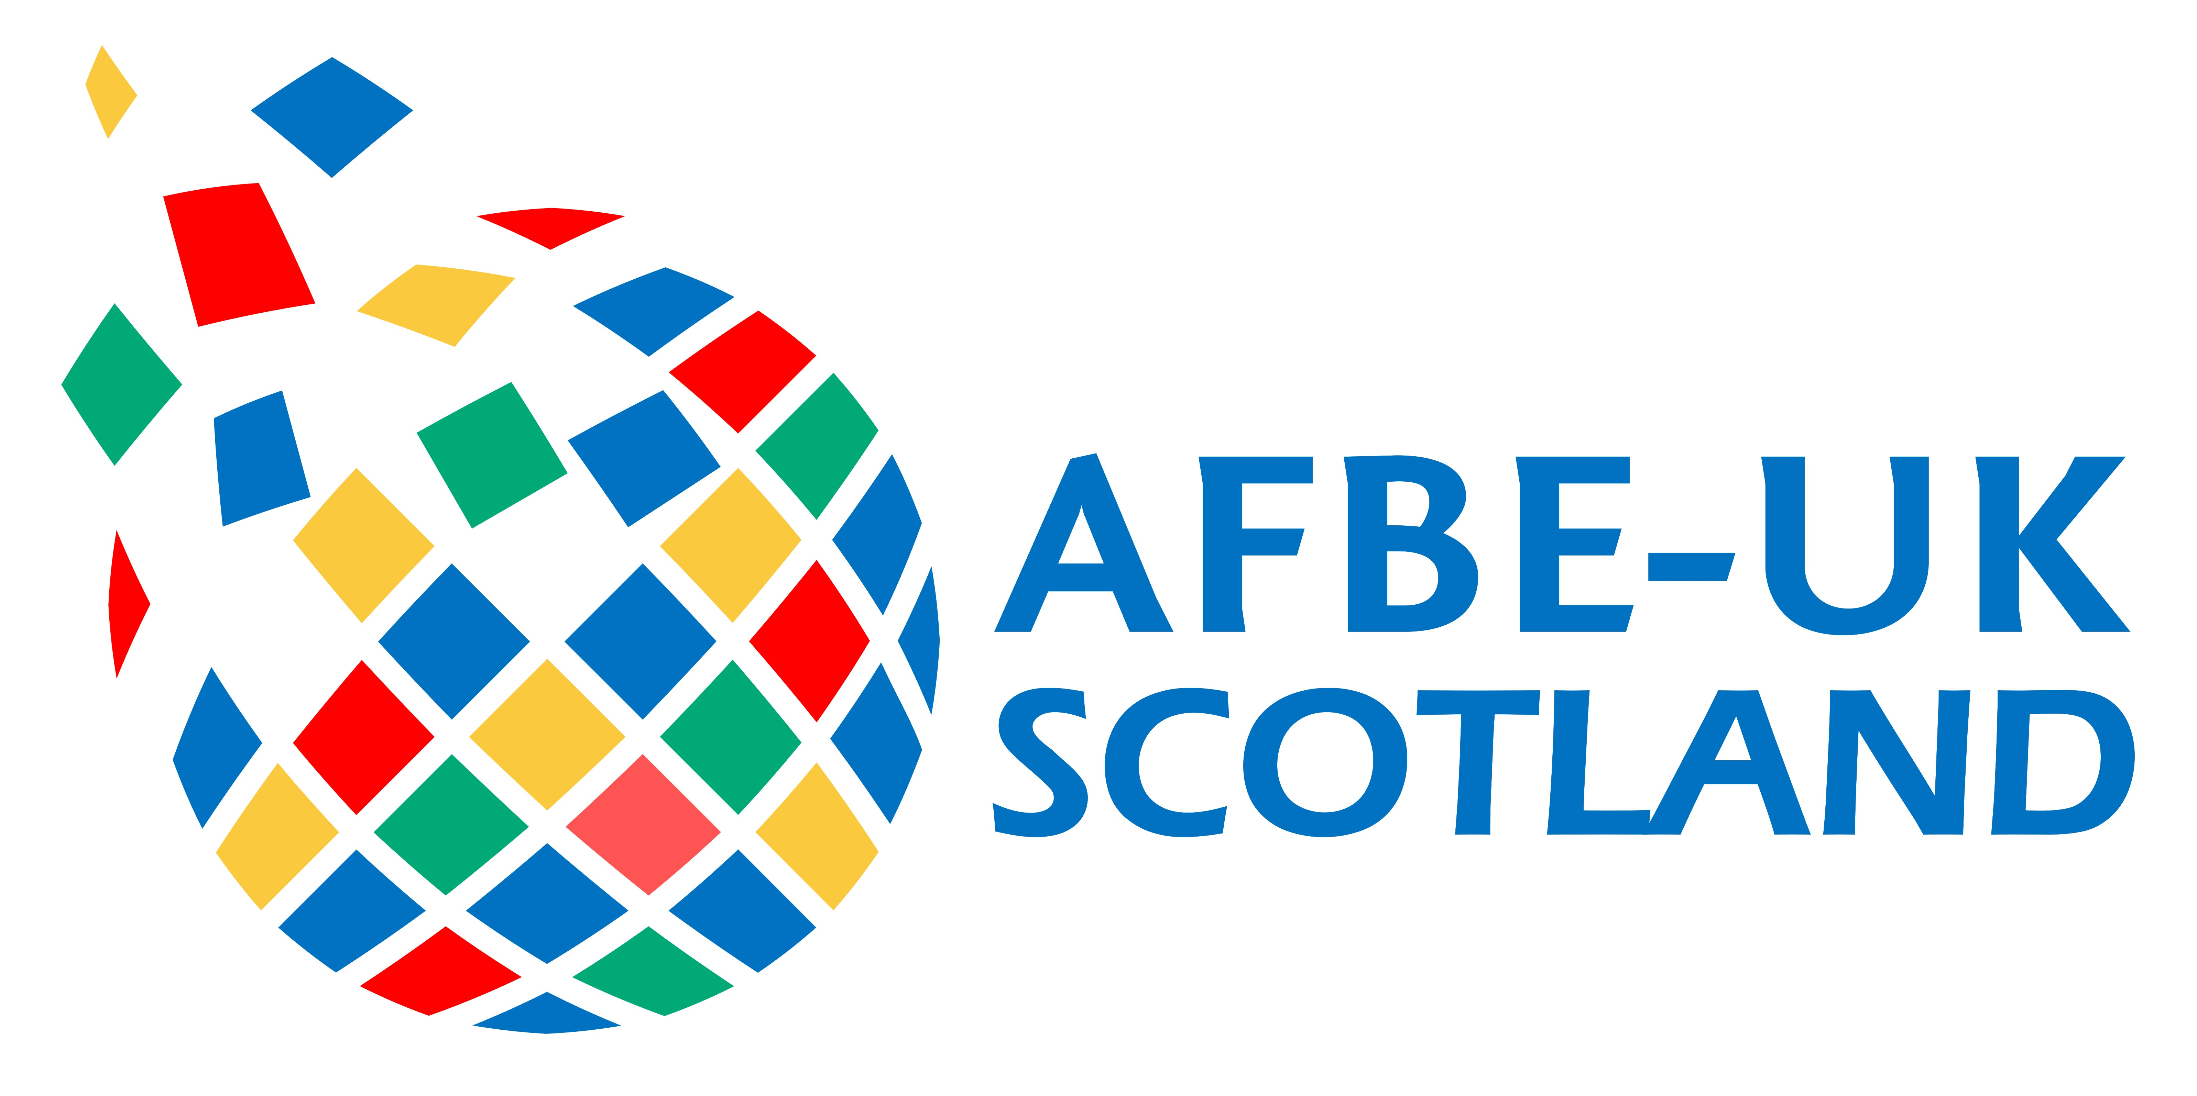
AFBE-UK Scotland Awards 2020

COMPANY OF THE YEAR AWARD

This Award is run by the AFBE-UK Scotland with the expressive purpose of encouraging and recognising an outstanding company in the area of diversity and inclusion.

Nominations can be made by the company applying, by an employee of the company or by a third party. This nomination should be an acknowledgement of this company’s effort to promote a more diverse and inclusive workforce.

- Any company can apply for this award

Nominated company

Company name
Address
Town
County
Postcode

Company Representative

Title
Name
Job title
Department
Phone no.
Mobile no.
Email

STRATEGY

Tell us how your company (or your nominated company) has sought to ensure an inclusive working environment and a diverse workforce. (E.g. gender, social class or ethnic diversity, support of local diversity initiatives helping people from ethnic minorities and/or females, diversity training for staff etc.)

Word limit: 500 words. Please use the space provided. Do not attach additional sheets.

LEADERSHIP

What steps has your company taken to encourage a more diverse management team (e.g. how many women or ethnic minorities does the company have on their executive board, diversity programme geared towards preparing female or BAME people within the company to senior roles etc.)?

Word limit: 500 words. Please use the space provided. Do not attach additional sheets.

Pictures

You may upload up to 2 photos/images to support your entry. Acceptable formats are JPG, GIF or BMP. Please ensure all items are embedded in the form; attachments will be deleted unread.

Picture 1

Picture 2

Please send your completed form to:

info@afbescotland.org

